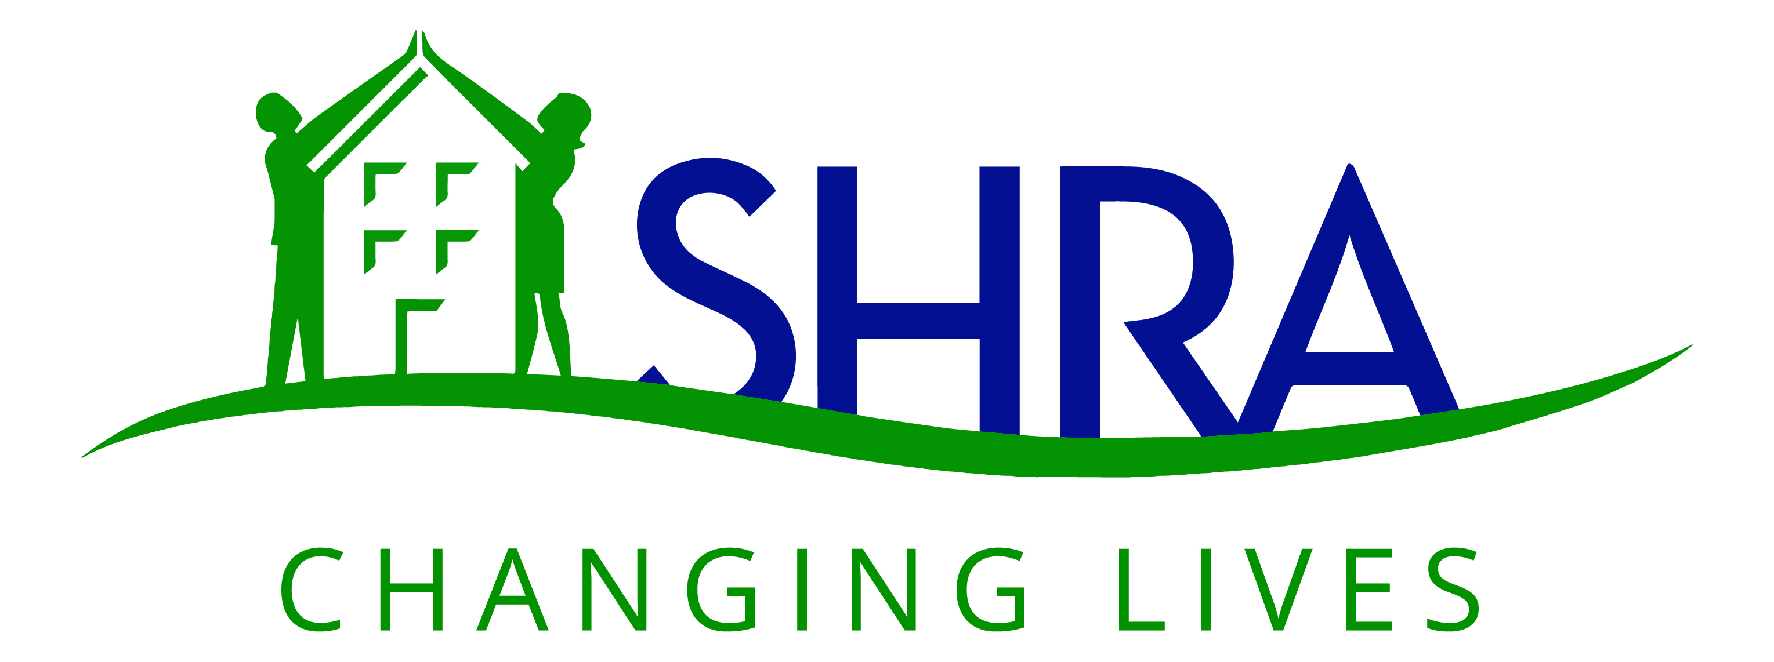 NOTICE OF REGULAR MEETING
Sacramento Housing and
Redevelopment Commission
TELECONFERENCE MEETING ONLY
Wednesday, December 2, 2020 – 6:00 pm
801 12th Street Commission Room
Sacramento CA

Meetings of the Sacramento Housing and Redevelopment Commission are closed to the public until further notice in compliance with state guidelines on social distancing, in accordance with the Brown Act, (as currently in effect under the State Emergency Services Act), the Governor’s Emergency Declaration related to COVID‐19, and the Governor’s Executive Order N‐29‐20 issued on March 17, 2020. These measures facilitate participation by members of the Commission, staff, and the public and allow meetings to be conducted by teleconference, videoconference, or both.

The Sacramento Housing and Redevelopment Commission meeting will be broadcast live on YouTube. To view the meeting please visit:
https://youtu.be/uCTo0R9eSyo

Members of the public who wish to make comments can do so in two ways:

- Email comments to publiccomments@shra.org which will be read into the record by the Clerk during the meeting.

- Comment by phone during the meeting by dialing (888) 970-1444. Please call and indicate if you wish to comment during the general ‘Citizens Comments’ period or on a specific agenda item.
Please contact the Agency Clerk’s office at 916-440-1363, if you have questions about the public comment procedure. In compliance with the Americans with Disabilities Act (ADA), SHRA requests that individuals who require special accommodations to access and/or participate in Commission meetings contact the office at (916) 440-1363 at least 24 hours before the scheduled meeting. Agenda materials are available for review online at www.shra.org. If you need assistance with locating reports contact the Agency Clerk at (916) 440-1363 for assistance.
ROLL CALL

APPROVAL OF AGENDA

Citizens Comments
While the Commission welcomes and encourages participation in the Commission meetings, please limit your comments to three minutes, so that everyone may be heard. SHRA provides opportunities for the public to address the Commission at this time in order to listen to opinions regarding non-agendized matters within the subject matter jurisdiction of SHRA. Consistent with the Brown Act, the public comment periods on the agenda are not intended to be “question and answer” periods or conversations with Commission members. Members of the public with questions are encouraged to contact staff before or after the meeting. Members of the public wishing to provide comment should either email comments to publiccomments@shra.org or be present them verbally by calling (888) 970-1444.

APPROVAL OF MINUTES – November 4, 2020

SPECIAL PRESENTATION

- Mirasol Village Project Update

DISCUSSION/BUSINESS ITEMS

- Tax Equity and Fiscal Responsibility Act Hearing and Approval of Tax-Exempt Bonds and Commitment of Housing Authority Successor Agency Funds to the Mirasol Village Block C Project (Twin Rivers Phase 3)

- Tax Equity and Fiscal Responsibility Act (TEFRA) Hearing, Approval of Tax-Exempt Bonds and Commitment of HOME and Housing Trust Funds to On Broadway Apartments

PRESENTATION

- Family Self Sufficiency (FSS) and Resident Services Program Presentations

EXECUTIVE DIRECTOR REPORT

COMMISSION CHAIR REPORT

ITEMS AND QUESTIONS OF COMMISSION MEMBERS

ADJOURNMENT

